AP Literature Summer Reading Novel Choices Payton 2017
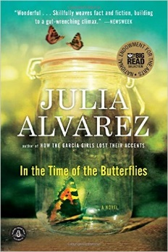 | In the Time of Butterflies by Julia Alvarez  It is November 25, 1960, and three beautiful sisters have been found near their wrecked Jeep at the bottom of a 150-foot cliff on the north coast of the Dominican Republic. The official state newspaper reports their deaths as accidental. It does not mention that a fourth sister lives. Nor does it explain that the sisters were among the leading opponents of Gen. Rafael Leonidas Trujillo’s dictatorship. It doesn’t have to. Everybody knows of Las Mariposas―“The Butterflies.” Amazon Review
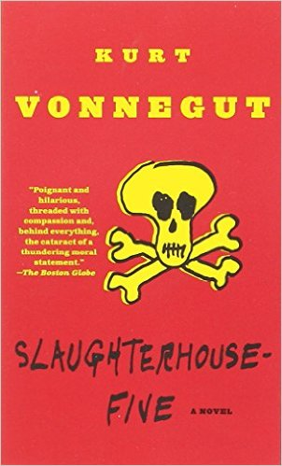 | Slaughterhouse-Five by Kurt Vonnegut  Kurt Vonnegut's absurdist classic Slaughterhouse-Five introduces us to Billy Pilgrim, a man who becomes unstuck in time after he is abducted by aliens from the planet Tralfamadore. In a plot-scrambling display of virtuosity, we follow Pilgrim simultaneously through all phases of his life, concentrating on his (and Vonnegut's) shattering experience as an American prisoner of war who witnesses the firebombing of Dresden.  Don't let the ease of reading fool you--Vonnegut's isn't a conventional or simple novel. Amazon Review
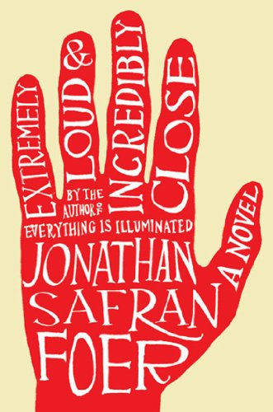 | Extremely Loud and Incredibly Close by Jonathan Safran Foer  -Oskar Schell is not your average nine-year-old. A budding inventor, he spends his time imagining wonderful creations. He also collects random photographs for his scrapbook and sends letters to scientists. When his father dies in the World Trade Center collapse, Oskar shifts his boundless energy to a quest for answers. He finds a key hidden in his father's things that doesn't fit any lock in their New York City apartment; its container is labeled "Black." Using flawless kid logic, Oskar sets out to speak to everyone in New York City with the last name of Black. A retired journalist who keeps a card catalog with entries for everyone he's ever met is just one of the colorful characters the boy meets.
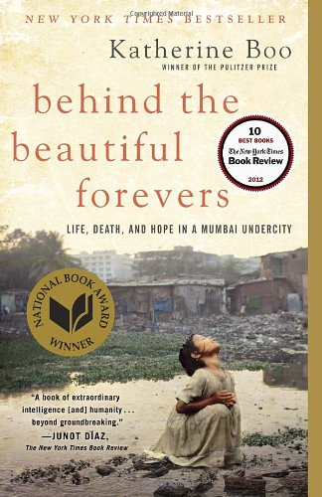 | Behind the Beautiful Forevers by Katherine Boo  In this brilliant, breathtaking book by Pulitzer Prize winner Katherine Boo, a bewildering age of global change and inequality is made human through the dramatic story of families striving toward a better life in Annawadi, a makeshift settlement in the shadow of luxury hotels near the Mumbai airport. As India starts to prosper, the residents of Annawadi are electric with hope. Abdul, an enterprising teenager, sees “a fortune beyond counting” in the recyclable garbage that richer people throw away. Booklist
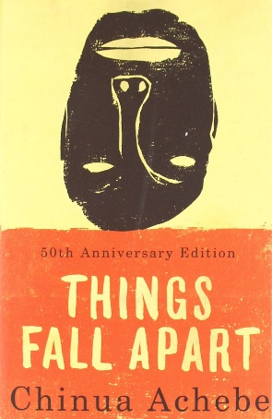 | Things Fall Apart by Chinua Achebe  Things Fall Apart tells two intertwining stories, both centering on Okonkwo, a “strong man” of an Ibo village in Nigeria. The first, a powerful fable of the immemorial conflict between the individual and society, traces Okonkwo’s fall from grace with the tribal world. The second, as modern as the first is ancient, concerns the clash of cultures and the destruction of Okonkwo's world with the arrival of aggressive European missionaries. These perfectly harmonized twin dramas are informed by an awareness capable of encompassing at once the life of nature, human history, and the mysterious compulsions of the soul. Booklist
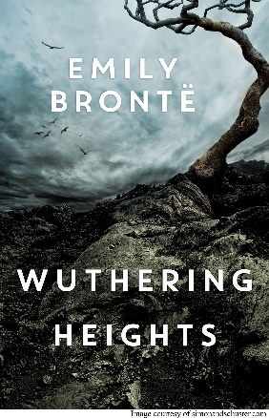 | Wuthering Heights—Emily Bronte  Wuthering Heights, the only novel that Emily Bronte wrote, is a classic of 19th century American literature. It is considered by many as one of the most important romantic novels ever written. Set in Northern England, Wuthering Heights is the story of Catherine Earnshaw and the love that she shares with Heathcliff. Catherine and Heathcliff are brought together as children when her father brings the young foundling home. The relationship between Catherine and Heathcliff is a tumultuous one of unfulfilled desire, betrayal, and bitter vengeance.

